Finding the formula of copper(II) oxide

Learning objectives
- Safely heat copper oxide with methane to reduce copper oxide to copper metal.
- Accurately record the change in mass.
- Explain the observed mass changes.
- Calculate the relative formula mass using experimental data.

Introduction

Copper oxide has lots of uses, including in ceramics and as a catalyst. To reduce the copper oxide, heat it in the presence of methane (CH₄). In this experiment you will also record the change in mass to calculate the formula of copper(II) oxide.

Equipment

Apparatus
- Safety glasses
- Reduction tube (hard glass test tube with small hole near closed end)
- One-hole bung with glass tube to fit the reduction tube
- Rubber tubing
- Clamp stand, boss and clamp
- Bunsen burner
- Heat resistant mat
- Spatula
- Balance (must be accurate to at least 0.01 g)

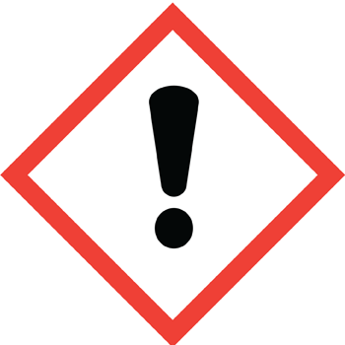
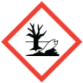
Chemicals
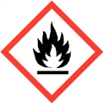
- Copper(II) oxide, 2 spatulas (HARMFUL, DANGEROUS FOR THE ENVIRONMENT),
- Methane (natural gas) (EXTREMELY FLAMMABLE)

Method
- Measure the mass of the test tube with the bung in (mass 1). Put 2 spatulas of copper(II) oxide into the tube and spread it out as much as possible.
- Measure the mass of the tube again, with the copper oxide in it (mass 2).
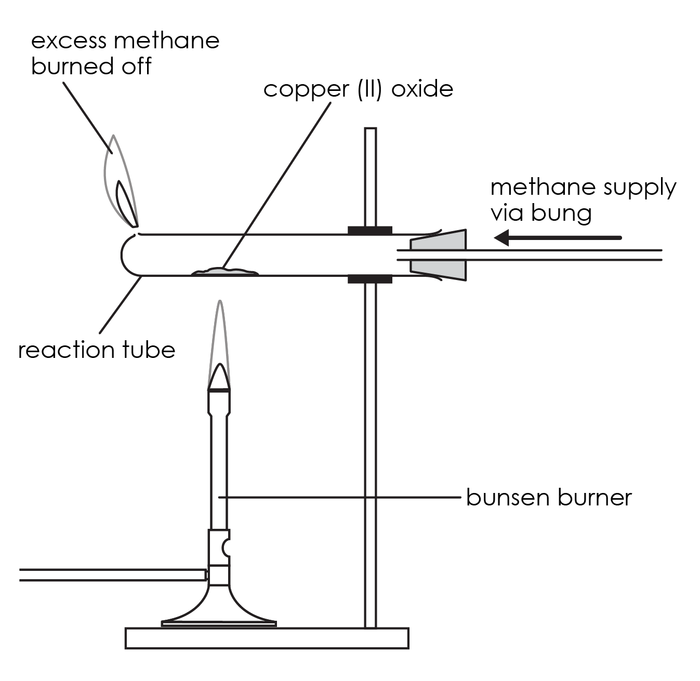
- Assemble the apparatus as shown in the diagram, but do not place the Bunsen burner underneath yet. Clamp the test tube as near to the bung as possible.
- Turn on the gas tap attached to the test tube about halfway to get a steady flow of gas. This will pass methane through the apparatus.
- Light the gas coming out of the hole at the end of the tube. Your teacher should supervise this step. Take care not to lean over the tube as you light the gas. Adjust the gas tap so that the flame is about 3 cm high.
- Light the Bunsen burner and begin to heat the copper oxide in the tube. You will need to use a roaring flame (air hole fully open). Pick up the Bunsen burner and move the flame around to heat every bit of the copper oxide. Make sure that you use the hottest part of the Bunsen burner flame (the top of the inner cone) for heating. If there are parts which look unreacted, gently shake the tube – it will be very hot, so do so by gently shaking the clamp stand.
- When all the copper oxide looks like it has reacted (it will look like copper), keep heating for a further minute or two and then turn off the Bunsen burner.
- Keep the methane passing over the product as it cools down to prevent it from reacting with any oxygen present and turning back into copper oxide. When the tube is cool, switch off the gas.
- Measure the mass of the test tube with the bung and the product (mass 3).

Results table
Mass 1 (g)  test tube + bung | Mass 2 (g)  test tube + bung + copper oxide | Mass 3 (g)  test tube + bung + copper (product)

Questions
- Describe your observations during this experiment.

__________________________________________________________________________________

__________________________________________________________________________________

- Explain why you saw these observations.

__________________________________________________________________________________

__________________________________________________________________________________

- Using your data above, calculate the mass of the copper oxide.

__________________________________________________________________________________

- Using your data above, calculate the mass of the copper.

__________________________________________________________________________________

- Using your data above, calculate the change in mass.

__________________________________________________________________________________

- Explain why the mass changed.

__________________________________________________________________________________

__________________________________________________________________________________

__________________________________________________________________________________

- Write a word equation for this reaction

__________________________________________________________________________________

Finding the formula of copper(II) oxide

To find the formula of copper oxide, you need to calculate the ratio between the number of moles of copper and the number of moles of oxygen in the compound.

The equation to calculate the number of moles is:

$$Number of moles of element= \frac{mass of element}{A_{r} of element}$$

The relative atomic mass ($A_{r}$) of copper is 65.5 and the $A_{r}$ of oxygen is 16.

To calculate the ratio, you need to divide the larger number of moles of element by the smaller number.

If the ratio is close to 1:1, the formula of magnesium oxide is $CuO$.
If the ratio is close to 1:2, the formula of magnesium oxide is $CuO_{2}$.
If the ratio is close to 2:1, the formula of magnesium oxide is ${Cu}_{2}O$.

Example calculation:

Mass of copper oxide = 1.76 g

Mass of copper = 1.43 g

So, mass of oxygen = 1.76 g – 1.43 g = 0.33 g

Number of moles of copper (Cu) = $\frac{mass of copper}{M_{r} of copper}$ = $\frac{1.43}{65.5}$ = 0.02251

Number of moles of oxygen (O) = $\frac{mass of oxygen}{M_{r} of oygen}$ = $\frac{0.33}{16}$ = 0.020625

Divide by the smallest number of moles of copper by the number of moles of oxygen to give the ratio:

$$Ratio of Cu:O=1:\frac{Number of moles of Cu}{Number of moles of O}=1:\frac{0.02}{0.02}=1:1$$
- Given the example above, calculate your ratio using your data.

__________________________________________________________________________________

__________________________________________________________________________________

__________________________________________________________________________________

What is the formula of copper oxide? ____________
- Using Q7 and Q8, state the balanced symbol equation for this reaction.

__________________________________________________________________________________
- Suggest why your results will be slightly different to others.

__________________________________________________________________________________

__________________________________________________________________________________

__________________________________________________________________________________

