Displacement reactions between metals and their salts

Learning objectives
- Safely carry out microscale displacement reactions.
- Make inferences about reactivity from displacement reactions.
- Represent and explain displacement reactions using equations and particle diagrams.
- Plan a practical to allow further inferences to be made from data.

Introduction

The reactivity of metals varies significantly depending on their position on the periodic table. The most reactive metals are found in group 1, the alkali metals, whereas the least reactive metals are found in the transition metals.

In this experiment, you will use a series of reactions to write a reactivity series for four metals, putting them in order from most to least reactive. When a strip of metal is added to a solution of a compound of another metal, a more reactive metal will displace (push out) a less reactive metal from its compound. You will add the metal to the metal compound and make observations on whether a reaction occurs or not.

Equipment

Apparatus
- Safety glasses
- Spotting tile, with at least 16 depressions (or two smaller tiles)
- Dropping (teat) pipette
- Beaker (100 cm³)
- Felt tip pen or other means of labelling

Chemicals

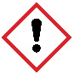
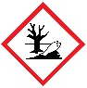
Access to about 5 cm³ each of the following 0.1 M metal salt solutions:
- Copper(II) sulfate, causes eye damage and TOXIC to aquatic life
- Magnesium nitrate(V)
- Iron(III) nitrate
- Zinc chloride

Five samples, approximately 1 cm lengths or squares, of each of the following metals:
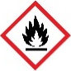
- Copper turnings
- Magnesium ribbon (FLAMMABLE)
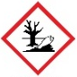
- Iron filings (or small nails)
- Zinc (powder or small granules) (FLAMMABLE)

Health and safety
- Wear safety glasses throughout.
- Beware of sharp edges when manipulating the metal strips.
- Copper(II) sulfate solution causes eye damage and is TOXIC to aquatic life.
- Magnesium ribbon is FLAMMABLE and gives off highly flammable gases in contact with acids.
- Zinc powder is FLAMMABLE and hazardous to the aquatic environment.

Method
- Using a dropping pipette, put a little of the zinc chloride solution in four of the depressions in the spotting tile, using the illustration below as a guide. Label this row with the name of the solution. Rinse the pipette well with water afterwards.
- Do this for each metal ion solution in turn, rinsing the pipette when you change solution.
- Put a piece of each metal in each of the solutions, using the illustration as a guide.
- Over the next few minutes observe which mixtures have reacted and which have not.
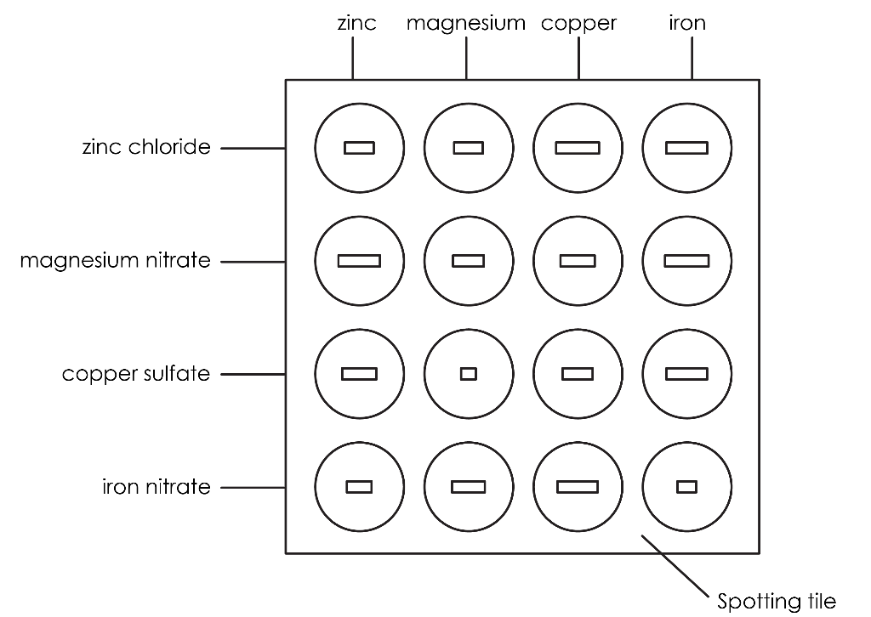

Results

Add a tick (✓) or cross (x) to the table to denote whether a chemical reaction was observed.
 | zinc | magnesium | copper | iron

zinc chloride

magnesium nitrate

copper sulfate

iron nitrate

Follow-up questions
- Below are a series of chemical reactions that you completed. For each one, state whether they did or did not react.
 |  | Yes | No
(a) | zinc + copper sulfate
(b) | copper + iron nitrate
(c) | iron + copper sulfate

- Describe the observations you made when magnesium reacted with copper sulfate that showed that a chemical reaction was occurring. Use the headings to support your answer.

Colour

__________________________________________________________________________________

__________________________________________________________________________________

State of substances

__________________________________________________________________________________

__________________________________________________________________________________
- Place the following metals in order of reactivity from most reactive to least reactive:

zinc, magnesium, copper, iron

Most reactive | ______________________________________
 | ______________________________________
 | ______________________________________
Least reactive | ______________________________________

- Complete the following word equations from your reactions:
- magnesium + copper sulfate $→$ ______________________ + ______________________
- zinc + copper sulfate $→$ ______________________ + ______________________
- magnesium + iron nitrate $→$ ______________________ + ______________________

- A student performs the experiment using a different metal, W. A reaction is seen between metal W and zinc chloride, iron nitrate and copper sulfate but not with magnesium nitrate. Determine whether metal W is more, or less, reactive than magnesium. Explain your answer.

Metal W is more/less reactive than magnesium as __________________________________

__________________________________________________________________________________

- A student wants to determine which metal salts metal X will react with. Metal X is more reactive than copper and less reactive than zinc. State which metal salts it will react with. Explain your answer.

Metal X would react with _________________________________ as ______________________ __________________________________________________________________________________

We don’t know if metal X will react with _________________________________ as ________ __________________________________________________________________________________

__________________________________________________________________________________
- Metals which are more reactive than copper will react exothermically with copper sulfate in displacement reactions. A temperature increase would be observed.
- Complete the sentence to define the term ‘exothermic’.

A chemical reaction which ________________ energy into the surroundings.

- Circle the independent variable (the one you change) in this experiment.
A | Mass of metal | B | Volume of copper sulfate
C | Type of metal | D | Temperature change

- Circle the dependent variable (the one you measure to give you results) in this experiment.
A | Mass of metal | B | Volume of copper sulfate
C | Type of metal | D | Temperature change

- Circle two control variables (the ones you keep the same) in this experiment.
A | Mass of metal | B | Volume of copper sulfate
C | Type of metal | D | Temperature change
- Name the piece of equipment used to measure temperature.

__________________________________________________________________________________
- A method for this experiment has been provided below but there are some errors. Read the method and rewrite it, making any corrections.

- Measure 20 cm³ of copper sulfate using a beaker.
- Record its initial mass using a thermometer.
- Measure 1 g of metal using a ruler.
- Add the metal to the beaker.
- Record the lowest temperature.
- Repeat one more time with this metal.
- Repeat for other metals, keeping the amount of copper sulfate and temperature constant.

__________________________________________________________________________________

__________________________________________________________________________________

__________________________________________________________________________________

__________________________________________________________________________________

__________________________________________________________________________________

__________________________________________________________________________________

__________________________________________________________________________________

__________________________________________________________________________________

__________________________________________________________________________________

__________________________________________________________________________________
- Metal X had a temperature change of 0°C. Explain this result.

__________________________________________________________________________________

__________________________________________________________________________________
- Metal Y reacted and had a temperature change of 1.5°C and Metal Z had a temperature change of 14.3°C. State which metal was the most reactive. Explain your answer.

Metal ______ is the most reactive. I know this because _______________________________

__________________________________________________________________________________

__________________________________________________________________________________

