Chromatography
- (a) What is the correct definition of a pure substance in chemistry?
Circle the correct answer. (1 mark)
- A substance containing two or more types of atom that are not bonded together.
- A substance that contains one type of element or compound only.
- A substance that is always naturally produced.
- A substance that contains two or more different types of element or compound.

(b) Which of these can be used to detect a pure substance?
Circle the correct answer. (1 mark)
- chromatography
- crystallisation
- evaporation
- filtration

(c) Which of the following statements is correct?
Circle the correct answer. (1 mark)
- Paper chromatography separates mixtures of soluble substances.
- Paper chromatography separates mixtures of insoluble substances.
- Paper chromatography separates mixtures of solvents.
- Paper chromatography separates mixtures with different boiling points.

- The image shows the setup and results from an experiment used to investigate whether a substance is pure.

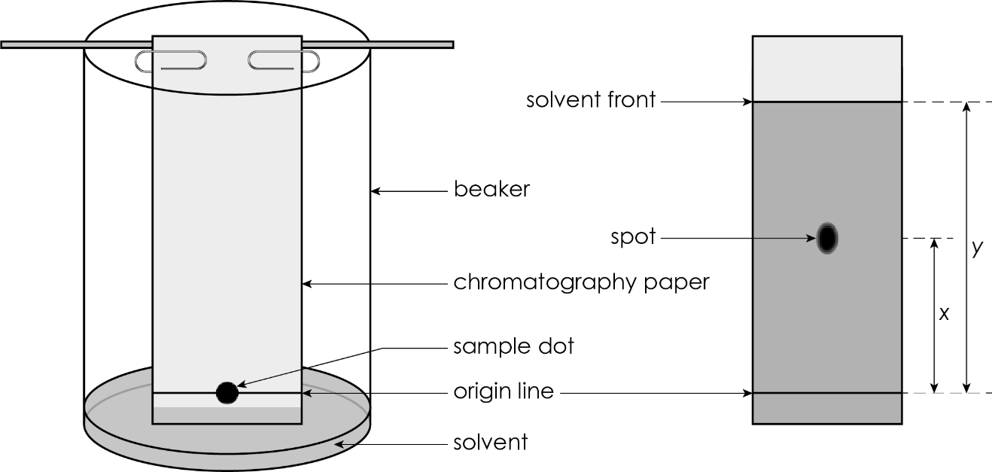
  - Identify the stationary phase.

__________________________________________________________________________ (1 mark)
  - Identify the mobile phase.

__________________________________________________________________________ (1 mark)
  - Give one reason why the level of the solvent must be below the sample dot and origin line.

(1 mark)
  - Look at the number of spots formed on the image.
- Is the sample a pure substance?

__________________________________________________________________________ (1 mark)
- Give a reason for your answer.

__________________________________________________________________________________

__________________________________________________________________________________
(1 mark)
  - What does the label x in the image represent?
Circle the correct answer. (1 mark)
- the distance moved by the solvent
- the distance moved by the spot
- the mobile phase
- the R_{f} value
  - What does the label y in the image represent?
Circle the correct answer. (1 mark)
- the distance travelled by the solvent
- the distance travelled by the spot
- the mobile phase
- the R_{f} value
- Students are using chromatography to investigate the coloured substances present in sweets. The image shows the chromatography paper before and after the investigation.

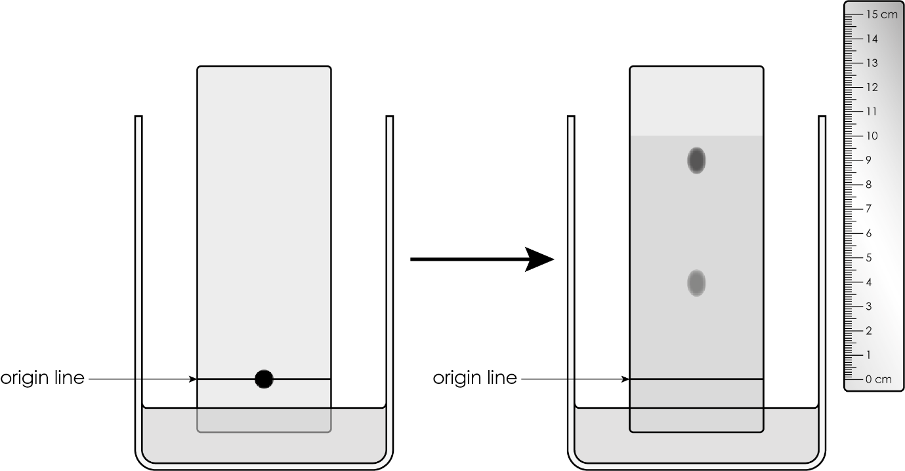
  - i. How many different substances are present in the sample?

__________________________________________________________________________ (1 mark)

ii. Give a reason for your answer.

__________________________________________________________________________________

__________________________________________________________________________ (1 mark)
  - i. Measure the distance travelled by the solvent.

__________________________________________________________________________ (1 mark)

ii. Measure the distance travelled by the higher spot.

__________________________________________________________________________ (1 mark)
- This equation is used to calculate the R_{f} value:

R_{f} $=$ $\frac{distance moved by spot}{distance moved by solvent}$

Calculate the R_{f} value for the higher spot.

__________________________________________________________________________________

_________________________________________________________________________ (2 marks)
  - Calculate the R_{f} value for the lower spot.

__________________________________________________________________________________

_________________________________________________________________________ (2 marks)
  - Select words from those provided to complete the sentences. You do not have to use all the words.

solvent measure R_{f} values

identify solute chemical tests

R_{f} values can be used to __________________ a substance. Each substance will always have the same R_{f} value in the same __________________ .

The R_{f} values calculated in question 3(b) and (c) can be compared with known __________________ .

(3 marks)

[Total: 21 marks]

