Chromatography
- Which statement is correct?
Circle the correct answer. (1 mark)

A. Paper chromatography separates mixtures of soluble substances.

B. Paper chromatography separates mixtures of insoluble substances.

C. Paper chromatography separates mixtures of solvents.

D. Paper chromatography separates mixtures with different boiling points.
- The image shows the setup and results from an experiment used to investigate whether a substance is pure.

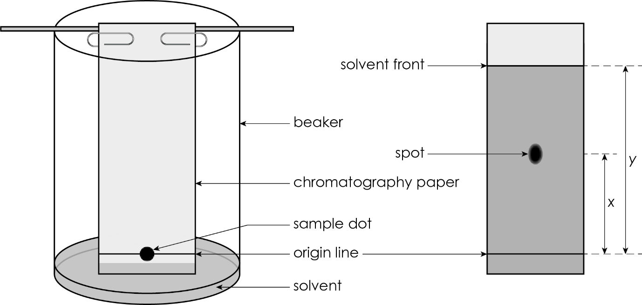
  - What is the meaning of a ‘pure substance’ in chemistry?

(1 mark)
  - i. Identify the stationary phase in the diagram.

__________________________________________________________________________ (1 mark)

ii. Identify the mobile phase in the diagram.

__________________________________________________________________________ (1 mark)
  - Is the sample likely to be a pure or an impure substance? Give a reason for your answer.

(2 marks)
  - What is represented by each of the following on the image:
- distance x

_________________________________________________________________________ (1 mark)
- distance y?

_________________________________________________________________________ (1 mark)
  - Write an expression for the R_{f} value in terms of distance x and distance y.

(1 mark)

- Students are using chromatography to investigate the coloured substances present in sweets. The image shows the chromatography paper before and after the investigation.

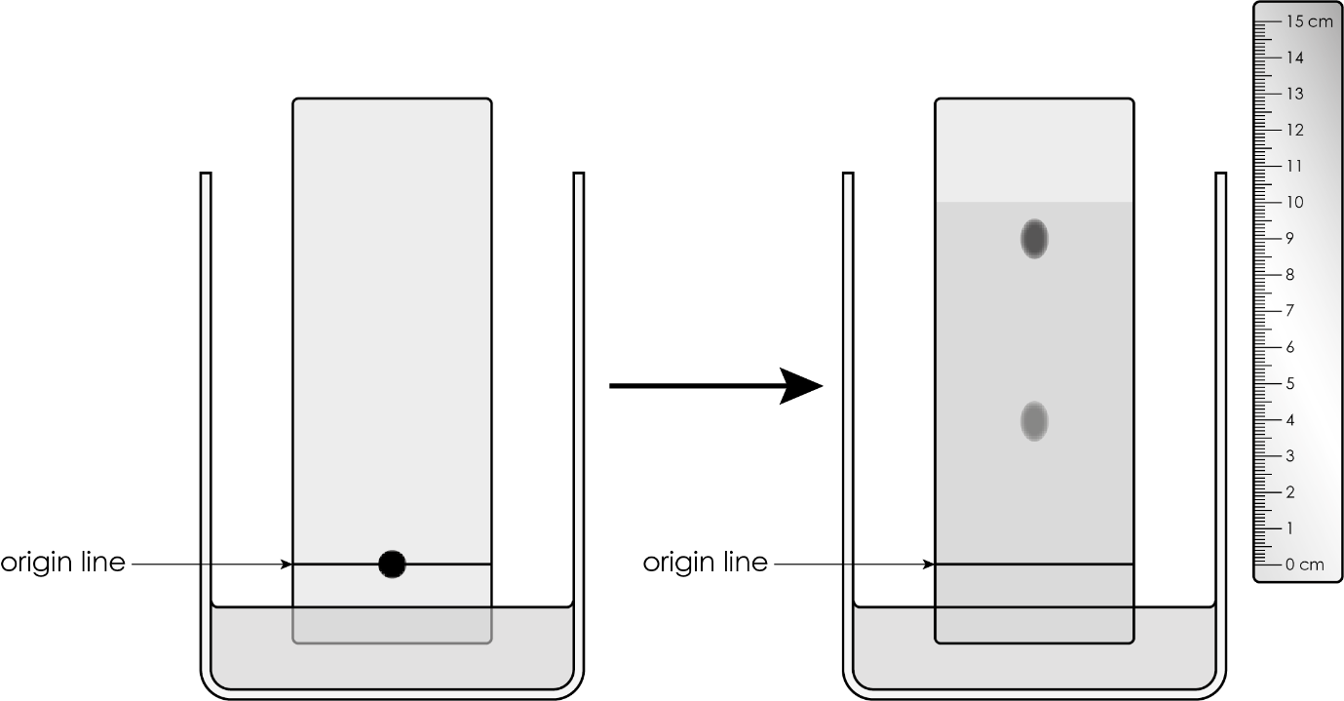
  - Is this sample being investigated a pure substance? Give a reason for your answer.

(2 marks)
  - Calculate the R_{f} values for each spot giving your answer as a fraction and a decimal:
- higher spot

(2 marks)
- lower spot

(2 marks)
  - i. Which of the spots produced has the greater attraction for the chromatography paper?

_________________________________________________________________________ (1 mark)

ii. Which of the spots produced has the greater solubility in the solvent?

_________________________________________________________________________ (1 mark)
  - Explain what determines how far a substance travels up the chromatography paper.

(2 marks)
- The table shows the distance moved by the solvent and the R_{f} values calculated from a paper chromatogram for three substances – X, Y and Z.
  - Complete the table to show the distance moved by each substance.
Substance | R_{f} value | Distance moved by solvent/cm | Distance moved by substance/cm
X | 0.5 | 10
Y | 0.0 | 10
Z | 0.7 | 10

(3 marks)
  - Suggest why substance Y has a R_{f} value of 0.0.

(1 mark)
  - Explain how the R_{f} values in the table could be used to identify substances X, Y and Z.

(1 mark)
  - Explain why the three substances move different distances up the paper.

(2 marks)

[Total: 26 marks]


Which question(s) did you get wrong? Why?

What will you do next time you’re asked a similar question?

