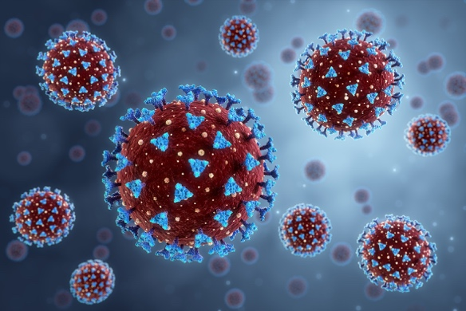
Chromatography

The image shows a COVID-19 virus under the microscope. The spikes on the surface are protein molecules. These protein spikes enable the virus to enter cells.
© Shutterstock

When scientists were developing COVID-19 vaccines, they needed to identify the spike protein on the virus. They used a special type of chromatography called liquid chromatography.

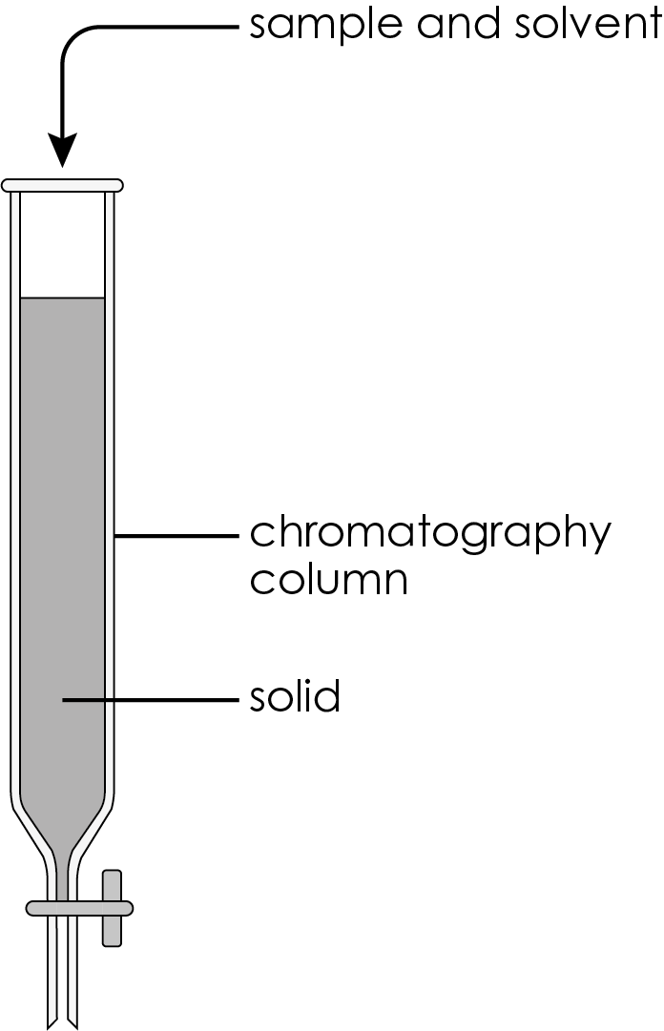
- In liquid chromatography, the sample is added to a solvent and allowed to filter down a column packed with a solid.
  - Name the stationary phase.

  - Name the mobile phase.

  - Which statement explains why different components in the sample travel down the column at different rates? Circle the correct answer.
- All the components have the same attraction to the stationary phase.
- All the components have the same attraction to the mobile phase.
- All the components have the same attraction to both mobile and stationary phases.
- Different components have different attractions to the mobile and stationary phases.
- The different components in the sample mixture move down the column and filter through the solid at different speeds.

The diagram shows how liquid chromatography works (Time 1, Time 2 and Time 3 represent the changes in the chromatography column over time).

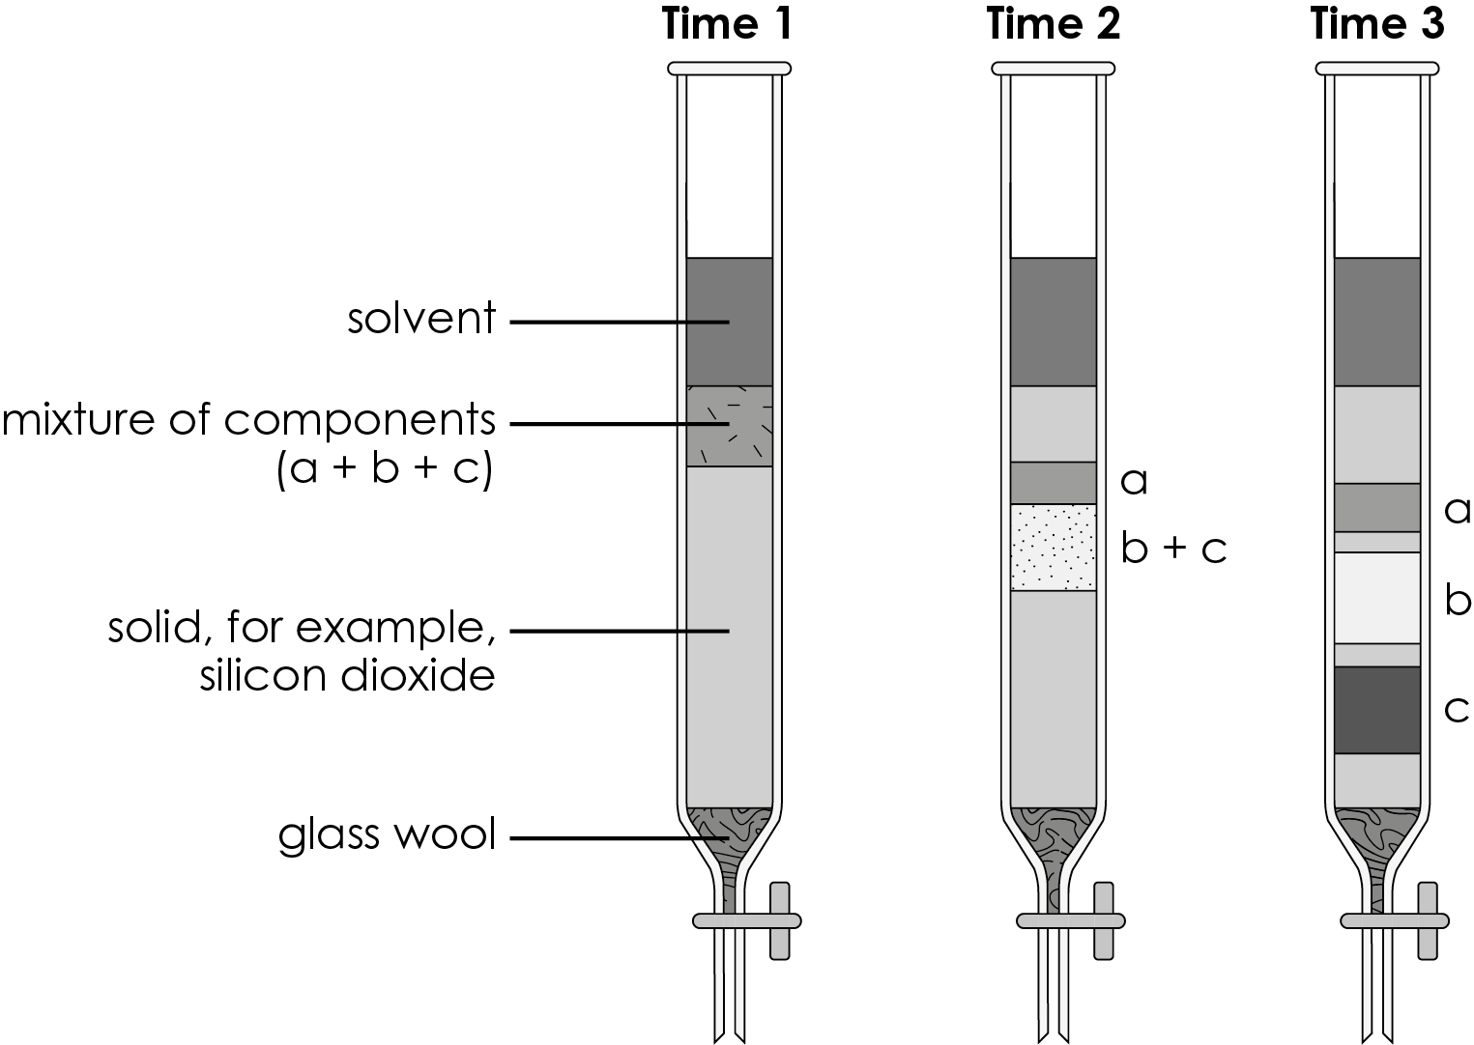
  - Describe what is happening to the mixture of components at:
- Time 1

- Time 2

- Time 3.

  - Suggest how scientists can collect pure samples of components a, b
and c.

  - Give two ways in which liquid chromatography differs from paper chromatography.

1. _____________________________________________________________________

2. _____________________________________________________________________
  - R_{f} values are also used in liquid chromatography. Complete the table to calculate the R_{f} values for components a, b and c. Give your answers to two significant figures.
Component | Distance moved by component/cm | Distance moved by solvent/cm | R_{f} value
a | 3 | 21
b | 10 | 21
c | 15 | 21

- Spike proteins on the COVID-19 virus were separated from the rest of the virus and broken up (digested) into smaller parts (peptides). The mixture of peptides is then separated by chromatography.
  - Describe how liquid chromatography was used to separate the mixture of peptides into pure peptides.

  - Scientists then used instrumental methods to identify the peptides. Give two reasons why instrumental methods were used rather than chemical tests.

1. _____________________________________________________________________

2. _____________________________________________________________________


Which question(s) did you get wrong? Why?

What will you do next time you’re asked a similar question?

