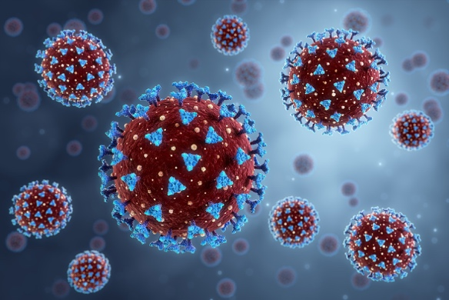
Chromatography

The image shows a COVID-19 virus under the microscope. The spikes on the surface are protein molecules. These spike proteins enable the virus to enter cells.
© Shutterstock

When scientists were developing COVID-19 vaccines, they needed to identify the spike protein on the virus. To do this they used a special type of chromatography called liquid chromatography.

- The image shows a column used in liquid chromatography.

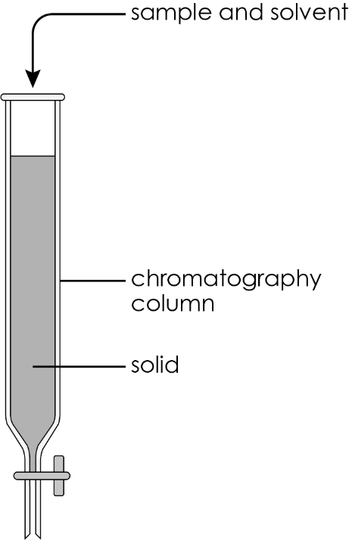

The column is filled with a solid like silicon dioxide. The sample and solvent are added from the top.
  - Select words from those provided to name each of the following phases.

the solvent the sample the glass column the solid
- the stationary phase

- the mobile phase

  - The components in the sample mixture move down the column and filter through the solid at different speeds.

The diagram shows how liquid chromatography works. Time 1, Time 2 and Time 3 represent the changes in the chromatography column over time.

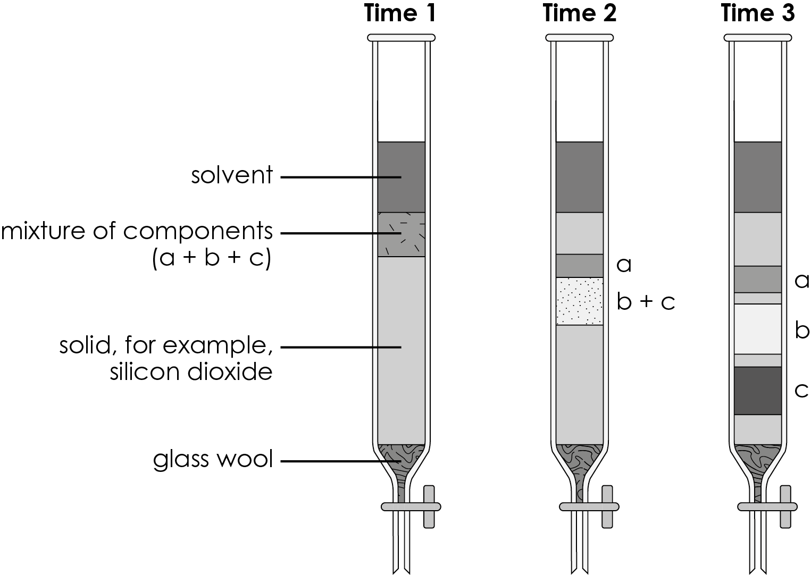

Which statement best explains why there is a plug of glass wool above the tap? Circle the correct answer.

A. To stop the solvent moving through the column

B. To prevent the stationary phase (silicon dioxide) from leaving the column

C. To separate the mixture of components

D. To absorb components a, b and c
  - Select words or letters from those provided to explain the observations.

a b c solvent separated

At Time 1, the mixture of components a, b and c and the __________________ have been added to the column.

At Time 2, the component __________________ has been separated from components __________________ and __________________ .

At Time 3, all three components have been __________________ .
  - Which component (a, b or c) is most attracted to the solvent?

  - Which component (a, b or c) is most attracted to the solid in the column?

  - Which of the following are likely to be pure substances?
Circle the correct answers.

component a component b component c

the solvent the solid in the column
  - R_{f} values are also used in liquid chromatography.

The R_{f} value of a substance $=$ $\frac{distance moved by substance}{distance moved by solvent}$ .

Calculate the R_{f} value for component c. Give your answer to two significant figures.

Distance travelled by solvent $=$ 21 cm

Distance travelled by component c $=$ 15 cm

R_{f} $=$ ____________________________________________________________________
- Scientists separated the spike proteins on the COVID-19 virus from the rest of the virus. The spike proteins were broken up (digested) into a mixture of smaller parts called peptides.
  - Which statement best explains how liquid chromatography separated the mixture of peptides? Circle the correct answer.
- The mixture was added to a column containing a solid substance.
- The mixture and a solvent were added to a column containing a solid substance and allowed to filter down.
- The solid substance was added to a column containing the mixture and a solvent.
- The solid substance and the mixture were added to the solvent in the column.
  - Give two reasons why scientists chose to use instrumental methods to identify the peptides rather than chemical tests.

1. _____________________________________________________________________

2. _____________________________________________________________________
  - Complete the table to compare paper chromatography with liquid chromatography. Add ticks () or crosses(x) to indicate whether each statement applies to paper chromatography, liquid chromatography or both.
 | Paper chromatography | Liquid chromatography

uses a stationary and a mobile phase

separates a mixture into pure substances

pure substances can be collected


Which question(s) did you get wrong? Why?

What will you do next time you’re asked a similar question?

