Leaf chromatography

Learning objectives
- Carry out paper chromatography to find the pigments present in leaves and calculate their R_{f} values.
- Identify stationary and mobile phases in paper chromatography.
- Describe what the chromatogram can tell us about substances.
- Explain why water is not always used as the solvent in chromatography.

Introduction

Most leaves are green due to the chemical chlorophyll. This substance is important in photosynthesis (the process by which plants make their food). In this experiment, you will investigate the different pigments present in a leaf, from chlorophyll to carotenes, using a technique called paper chromatography.

Chromatography has many real-world applications. These include testing the purity of foods and medicines, identifying the use of performance enhancing drugs during sports competitions, and testing for traces of explosives and accelerants from fires.

Equipment

Apparatus
- Safety glasses
- Pestle and mortar
- Chromatography paper
- Beaker, 100 cm³
- Small capillary tube
- Pencil
- Ruler
- Cut-up leaves (or leaves and scissors)

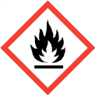

Chemicals
- Propanone (HIGHLY FLAMMABLE, IRRITANT)
- Sand

Method
- Finely cut up some leaves and fill the mortar to a depth of about 2 cm.
- Add a pinch of sand and about six drops of the propanone from the teat pipette.
- Grind the mixture with a pestle for a minimum of three minutes.
- On a strip of chromatography paper, draw a pencil line 3 cm from the bottom.
- Use a capillary tube to put the liquid from the leaf extract on to the centre of the line. Keep the spot as small as possible.
- Allow the spot to dry, then add another spot directly on top. Repeat this five times, letting each drop dry before adding the next. This concentrates the pigment.
- Secure your chromatogram carefully to ensure that it sits just above the base of the beaker.
- Place no more than 10 cm³ of propanone into the beaker, and hang your chromatogram so that it dips into the propanone but does not submerge the pencil line. Add a lid to your beaker.
- Allow the propanone to travel about ¾ of the way up the chromatography paper and then remove the chromatogram.
- Mark with a pencil how high up the paper the propanone gets and allow the chromatogram to dry.
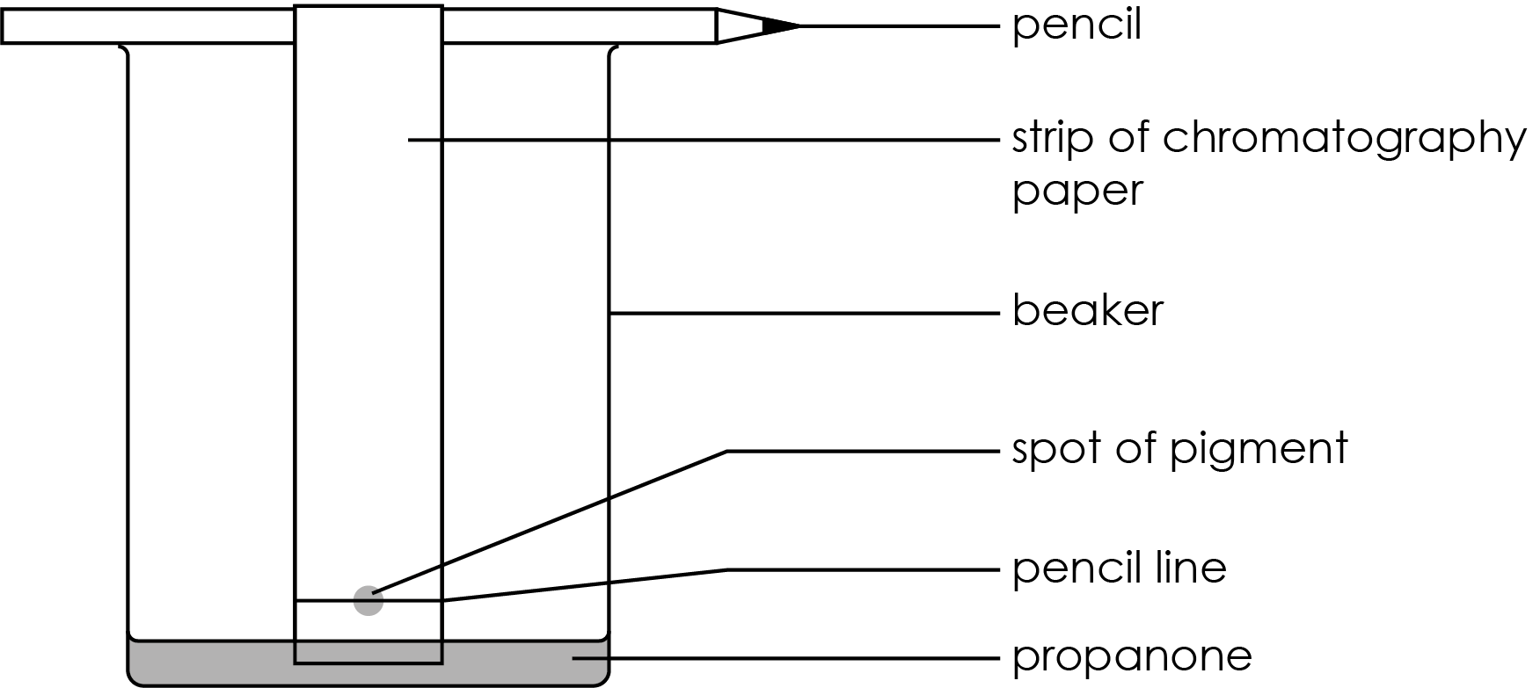

Results

On the diagram below, sketch a diagram of your finished chromatogram. Measure the distances and add them to the results table.
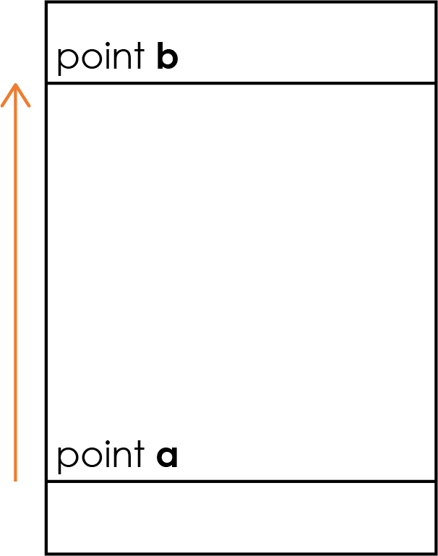
Distance travelled by sample = ____________ cm (= distance between point a and the centre of the spot).
If there are multiple sample spots, calculate the distance for each spot separately

Distance travelled by solvent = ___________ cm
(= distance between point a and point b)

Spots of leaf sample | Distance travelled |  | R_{f}
Spots of leaf sample | By spot | By solvent | R_{f}

Questions
- State the stationary and mobile phase in this chromatography experiment.
Stationary phase = _____________________________________
Mobile phase = ________________________________________
- Explain why water was not used as the solvent in this chromatography experiment.

__________________________________________________________________________________

__________________________________________________________________________________

__________________________________________________________________________________
- Explain why the markings on the chromatography paper must be drawn in pencil (and not in pen).

__________________________________________________________________________________

__________________________________________________________________________________

__________________________________________________________________________________

__________________________________________________________________________________
- State and explain which of the chemicals (using the spot numbers) within the leaf pigment was the most soluble in the solvent.

__________________________________________________________________________________

__________________________________________________________________________________

__________________________________________________________________________________

__________________________________________________________________________________
- Using your chromatogram, is the pigment found within the dye a pure substance or a mixture? Explain how you can tell.

__________________________________________________________________________________

__________________________________________________________________________________

__________________________________________________________________________________

__________________________________________________________________________________
- Look at the example data provided by your teacher.
- Why did spot 1 not travel up the chromatography paper?

__________________________________________________________________________________

__________________________________________________________________________________
- Why did spots 2, 3 and 4 travel different distances up the chromatography paper?

__________________________________________________________________________________

__________________________________________________________________________________

__________________________________________________________________________________

__________________________________________________________________________________

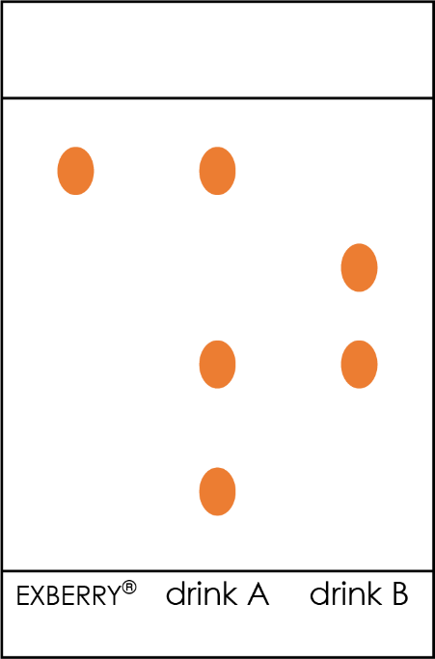
- Carotenes are natural pigments produced by plants, algae and some bacteria, fungi and archaea. EXBERRY®, a brand of plant-based carotene food colouring extracted from saltwater algae Dunaliella salina, is used in a number of food and drink items. A student wanted to investigate whether this food colouring is used in two different soft drinks, A and B. The results are shown on the chromatogram to the right.

Use the chromatogram to draw two conclusions about the colourings used in drinks A and B.

Conclusion 1:

__________________________________________________________________________________

__________________________________________________________________________________

__________________________________________________________________________________

__________________________________________________________________________________

Conclusion 2:

__________________________________________________________________________________

__________________________________________________________________________________

__________________________________________________________________________________

__________________________________________________________________________________

