Representing elements and compounds
- This question is about the chemical formulas of molecular substances.
  - The diagram shows the ball and stick model of a molecule of the element sulfur.

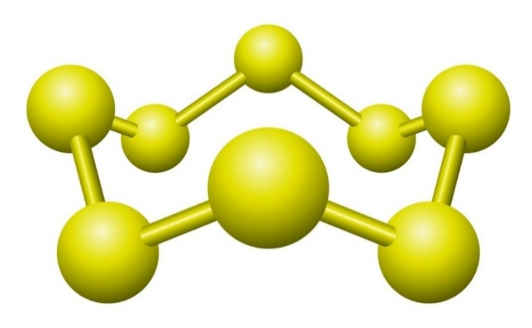

Source: © Shutterstock

What is the chemical formula for this sulfur molecule?

_________________________________________________________________________ (1 mark)
  - Complete the table on the next page to show the name and number of atoms in the chemical formulas of some molecular compounds. The first row has been completed for you.
Chemical formula of compound | Name of atoms in the compound | Number of each type of atom in the compound
$$CH_{3}COOH$$ | carbon  hydrogen  oxygen | 2 carbon atoms  4 hydrogen atoms  2 oxygen atoms
$$C_{2}H_{6}$$
$$CH_{3}{(CH_{2})}_{3}CH_{3}$$
$$H_{2}NCH_{2}COOH$$
$$HOOC{(CH_{2})}_{4}COOH$$
(4 marks)
- This question is about the chemical formulas of ionic compounds.
  - The formula of sodium chloride is $NaCl$. What type of formula is $NaCl$?

_________________________________________________________________________ (1 mark)
  - Each of the following compounds contains group 1 and group 7 elements. Deduce their formulas.
- lithium fluoride

__________________________________________________________________ (1 mark)
- potassium iodide

__________________________________________________________________ (1 mark)
- sodium bromide

__________________________________________________________________ (1 mark)
  - What is the difference in composition between calcium sulfide and calcium sulfate?

__________________________________________________________________________________

__________________________________________________________________________________
(1 mark)
  - Each of the following ionic compounds is formed when group 1 or
group 2 positive ions combine with group 6 or group 7 negative ions.

Deduce the chemical formula of each compound.
- sodium oxide

________________________________________________________________ (1 mark)
- magnesium chloride

________________________________________________________________ (1 mark)
- calcium sulfide

________________________________________________________________ (1 mark)

  - Use the formulas of the ions provided to deduce the chemical formulas of each of the following ionic compounds.

$${NH_{4}}^{+} {OH}^{-} {NO_{3}}^{-} {CO_{3}}^{2-} {SO_{4}}^{2-}$$
- sodium carbonate

_________________________________________________________________ (1 mark)
- magnesium nitrate

_________________________________________________________________ (1 mark)
- ammonium hydroxide

_________________________________________________________________ (1 mark)
- ammonium sulfate

_________________________________________________________________ (1 mark)
- magnesium carbonate

_________________________________________________________________ (1 mark)
- State symbols provide more information about a substance.

Add state symbols to each of the chemical equations provided based on the information given in the description of the reaction that occurs.
  - An iron nail is placed in copper(II) sulfate solution. The iron nail reacts with the copper(II) sulfate to produce copper metal and a solution of
iron(II) sulfate.

$Fe__________ + CuSO_{4}__________ ⟶ Cu__________ + FeSO_{4}__________$ (2 marks)
  - When copper carbonate powder is added to dilute hydrochloric acid, carbon dioxide gas is given off and a green solution is formed.

$$CuCO_{3}_________ + 2HCl_________ ⟶ Cu{Cl}_{2}_________ + CO_{2}_________ + H_{2}O_________$$

(2 marks)

- Copper forms a ${Cu}^{+}$ ion and a ${Cu}^{2+}$ ion. Roman numerals are used in the name of ionic compounds to show the number of positive charges on the metal ion.
  - Name each of these compounds.
- ${Cu}_{2}O$

_______________________________________________________________ (1 mark)
- $CuO$

________________________________________________________________ (1 mark)
- $CuCl$

________________________________________________________________ (1 mark)
  - Give the chemical formula for each of the following compounds:
- iron(II) oxide

________________________________________________________________ (1 mark)
- iron(III) oxide

________________________________________________________________ (1 mark)
- manganese(IV) oxide

________________________________________________________________ (1 mark)

[Total: 28 marks]


Which question(s) did you get wrong? Why?

What will you do next time you’re asked a similar question?

