Representing elements and compounds

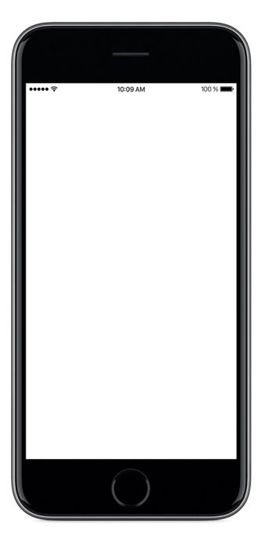
Smartphones are made from about 30 different elements. These are some of them.
Wiring and electronics
Copper is used for wiring and electronics, along with gold, silver and tantalum.
Smartscreen
A smartscreen has two layers of glass made from aluminium oxide and silicon dioxide with a coating of indium tin oxide.

Microphone and vibrations
Nickel is used in the microphone. Alloys containing rare earth elements are used in the speaker and vibration unit.
The silicon chip
Pure silicon is used to make the silicon chip.

Colours
Rare earth compounds produce colours on the screen.

Source: © Shutterstock

- (a) Aluminium is in group 3 of the periodic table and silicon is in group 4. Write the chemical formulas for:
- aluminium oxide

- silicon dioxide

(b) Both of the compounds in question 1(a) have giant structures. What type of formulas do these giant structures have?

(c) The coating of indium tin oxide on the glass of a smartscreen conducts electricity. When you touch the smartscreen, you complete an electric circuit and the touch is detected.

Indium tin oxide is a mixture of 90$\%$indium oxide and 10$\%$tin oxide. The formula of indium oxide is ${In}_{2}O_{3}$.
- Tin ($Sn$) is in group 4. Deduce the empirical formula of tin oxide.

- Calculate the relative formula mass of indium oxide.

A_{r} indium $=$ 115, A_{r} oxygen$=$ 16

- Calculate the percentage by mass of indium in indium oxide.

- Tantalum ($Ta$) is a transition element used in the electronics of a smartphone. Tantalum compounds found in rocks usually contain the ${Ta}^{5+}$ ion.
  - What is the chemical formula of tantalum(V) oxide?

  - Calculate the relative formula mass of tantalum(V) oxide.

A_{r} tantalum $=$ 181; A_{r} oxygen $=$ 16

  - Calculate the maximum mass of tantalum that can be extracted from
2210 g tantalum(V) oxide.

  - Tantalum also forms the ions ${TaO_{4}}^{3-}$ and ${TaO_{3}}^{-}$.
- Write the chemical formula for the compound formed when ${TaO_{4}}^{3-}$ is combined with lithium.

- Write the chemical formula for the compound formed when ${TaO_{3}}^{-}$ is combined with lithium.

- Silicon dioxide occurs as sand, clay and quartz. The silicon used to make chips in smartphones is extracted by reducing liquid silicon dioxide with solid carbon. Liquid silicon is produced.
  - Add state symbols to the equation below to show the reaction.

$SiO_{2}$__________ + $2C$__________ $⟶ Si$__________ $+ 2CO$__________
  - i. Calculate the mass of carbon needed to reduce 120 g of silicon dioxide.

A_{r} silicon = 28; A_{r} carbon = 12; A_{r} oxygen = 16

ii. Calculate the volume of carbon monoxide gas produced when 120 g of silicon dioxide reacts.

Hint: one mole of gas occupies 24 dm³ at room temperature and pressure.

  - Calculate the percentage atom economy of the reaction in question 3(a) to produce silicon.

- Neodymium ($Nd$) is an example of a rare earth metal and is used in speaker magnets and vibration units of smartphones. Its atomic number is 60.

Neodymium may not appear on your periodic table since some periodic tables omit elements with atomic numbers from 58 to 71.
  - The most common ion of neodymium is ${Nd}^{3+}$. Complete the table to show the molecular formulas of some compounds containing this ion.
Compound | Chemical formula

neodymium(III) chloride

neodymium(III) oxide

neodymium(III) sulfate
  - Neodymium also forms ${Nd}^{2+}$ ions.

Write the chemical formula for:
- neodymium(II) chloride

- neodymium(II) sulfide


Which question(s) did you get wrong? Why?

What will you do next time you’re asked a similar question?

