Solubility

The table summarises whether common ionic compounds are soluble or insoluble in water. You will need to refer to this information to answer question 1(b).
Soluble | Insoluble
all common sodium, potassium and ammonium salts
all nitrates
most common chlorides | silver chloride, lead chloride
most common sulfates | lead sulfate, barium sulfate, calcium sulfate
sodium carbonate, potassium carbonate, ammonium carbonate | most common carbonates
sodium hydroxide, potassium hydroxide, ammonium hydroxide | most common hydroxides

- (a) Which term correctly describes a solid substance that is dissolved
to make a solution? Circle the correct answer. (1 mark)
- saturated
- solute
- solvent
- unsaturated

(b) Which statement is true? Circle the correct answer. (1 mark)
- all ammonium salts are insoluble
- all group 1 chlorides are insoluble
- all group 1 salts are soluble
- all nitrates are insoluble

(c) The graph shows how the solubility of four different salts changes with temperature.

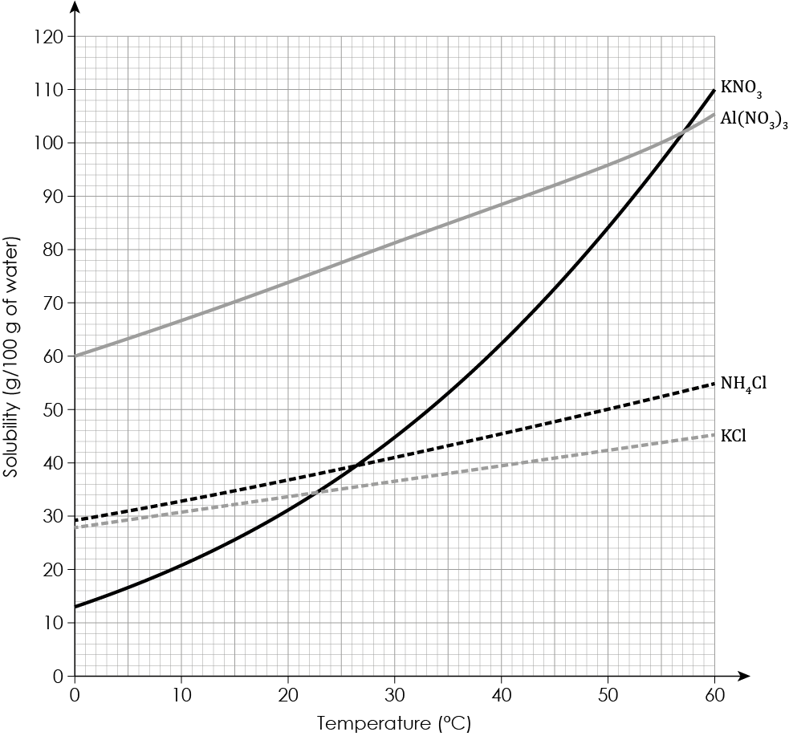
- What is the general trend in solubility as the temperature increases?

__________________________________________________________________________ (1 mark)
- At which temperature do $\text{KNO}\text{3}$ and $\text{NH}\text{4}\text{Cl }$have the same solubility?

__________________________________________________________________________ (1 mark)
- Calculate the mass of $Al(NO_{3})_{3}$that crystallises out when a saturated solution cools from 58°C to 0°C.

Hint: You should:
- determine the solubility of $Al(NO_{3})_{3}$ at 0°C
- determine the solubility of $Al(NO_{3})_{3}$ at 58°C
- calculate the difference between the two solubilities.

__________________________________________________________________________________

__________________________________________________________________________________ (2 marks)
- Complete the table to name the salts produced from the reactants.

The first salt has been named for you.
Acid | Alkali or base | Name of salt produced
hydrochloric acid | zinc oxide | zinc chloride
nitric acid | lithium hydroxide
sulfuric acid | magnesium oxide
ethanoic acid | calcium carbonate

(3 marks)
- This question is about the method used to prepare a soluble salt from an acid and an insoluble substance.
  - Complete the symbol equation, including state symbols, representing the reaction used to prepare copper(II) sulfate $(CuSO_{4}).$

$CuO(s)$ + ________ $(aq)$ ⟶ $CuSO_{4}$____ + _________ $(l)$ (2 marks)

The diagrams below show the first two stages in a method used to prepare copper(II) sulfate crystals:

A | 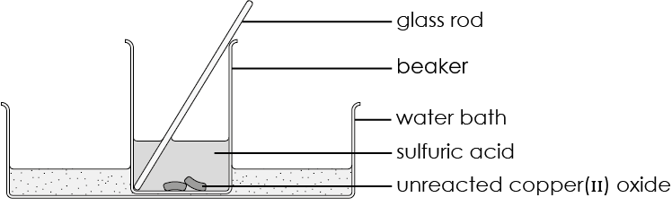
B | 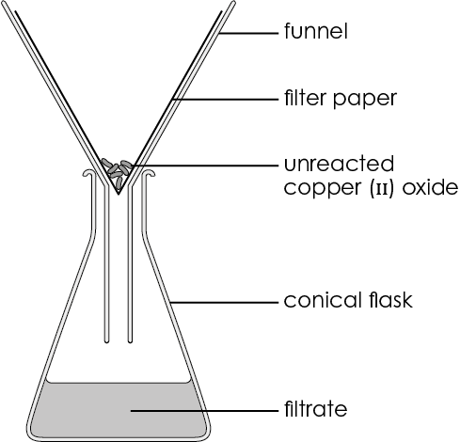
  - Give one reason why:
- an excess of copper oxide must be added to the sulfuric acid.

__________________________________________________________________________________

__________________________________________________________________________________

(1 mark)
- the reaction mixture is filtered.

__________________________________________________________________________________

__________________________________________________________________________________

(1 mark)
  - Describe a method to produce copper sulfate crystals from the filtrate in diagram B.

__________________________________________________________________________________

__________________________________________________________________________________

__________________________________________________________________________________

__________________________________________________________________________________

(2 marks)
- This question is about preparing an insoluble salt from two soluble salts.

Silver nitrate and sodium chloride are both soluble. A few drops of silver nitrate solution are added to sodium chloride solution. The image shows the product formed in the test tube.

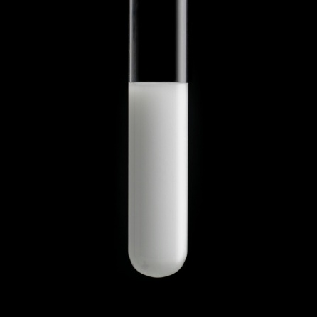

Source: © Science Photo Library
  - What is the general term used to describe a solid produced from solutions of two soluble salts?

__________________________________________________________________________ (1 mark)
  - The reaction between silver nitrate and sodium chloride can be represented using the equation:

$$AgNO_{3}(aq) + NaCl(aq) ⟶ AgCl(s) + NaNO_{3}(aq)$$
- Name the solid product.

_______________________________________________________________ (1 mark)
- Describe how a pure, dry sample of the solid product can be obtained from the mixture in the test tube.

__________________________________________________________________________________

__________________________________________________________________________________

__________________________________________________________________________________

(3 marks)

[Total: 20 marks]


Which question(s) did you get wrong? Why?

What will you do next time you’re asked a similar question?

