Filtration

Introduction

These questions are designed to help you to develop your mental models (pictures in your head) of symbols and formulae. Use the icon in the margin to find out which level of understanding the question is developing.
 | Macroscopic: what we can see. Think about the properties that we can observe, measure and record.
 | Sub-microscopic: smaller than we can see. Think about the particle or atomic level.
 | Symbolic: representations. Think about how we represent chemical ideas including symbols and diagrams.

Questions

- Coffee beans can be ground to make a powder. When ground coffee is mixed with hot water, some of the coffee dissolves and some of the powder remains. The remaining pieces of powder are called ’coffee grounds’. The coffee grounds can be separated from the dissolved coffee drink using a filter. This process is called filtration. The dissolved coffee drink is the filtrate and the coffee grounds are the residue.

Add labels to diagram to show the filtrate and the residue.


- When cooking, it is important to be able to separate foods from the water they are cooked in.

- List these three pieces of cooking equipment in order of hole size. Start with the piece of equipment with the largest holes.

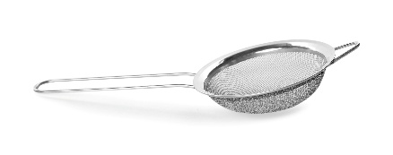 | 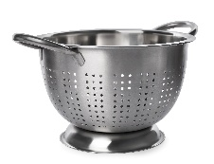 | 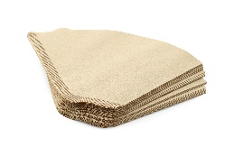
Image ©: Shutterstock/New Africa | Image ©: Shutterstock/New Africa | Image ©: Shutterstock/New Africa
sieve | colander | filter paper

________________________ ________________________ ________________________

largest holes smallest holes

- List the food in order of size.
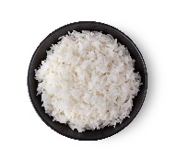 | 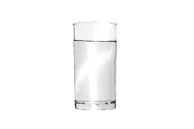 | 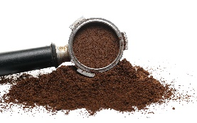 | 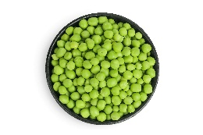
Image ©: Shutterstock/pukao | Image ©: Shutterstock/KorArkaR | Image ©: Shutterstock/xpixel | Image ©: Shutterstock/Nataly Studio
rice grains | water particles | coffee grounds | peas

__________________ __________________ __________________ __________________

largest smallest
- The table shows which foods pass through which pieces of equipment.
 | Colander | Sieve | Filter paper
rice | ü | X | X
water | ü | ü | ü
ground coffee | ü | ü | X
peas | X | X | X

Name the piece or pieces of equipment that could separate the following from water.
- peas _____________________________________
- coffee grounds _____________________________________

- The process of separating a mixture using a sieve is called sieving. Sieving is a different process to filtration. Write a sentence to explain why sieving can be used to separate rice from water.

_________________________________________________________________________________

__________________________________________________________________________________
- Write a sentence to explain why sieving cannot be used to separate coffee grounds from the ready-to-drink dissolved coffee.

_________________________________________________________________________________

__________________________________________________________________________________
- Sand, mud and powders are made up of tiny pieces of solid. Salt is made up of small crystals.

- State whether the following are visible or not visible to the human eye.
- a speck of mud ______________________
- a speck of powdered chalk ______________________
- a salt crystal ______________________
- a particle of dissolved salt ______________________
- a particle of water ______________________
- State whether the following are larger or smaller than the holes in filter paper.
- a speck of mud ______________________
- a speck of powdered chalk ______________________
- a salt crystal ______________________
- a particle of dissolved salt ______________________
- a particle of water ______________________
- A substance which dissolves in water is soluble. A substance which does not dissolve in water is insoluble. Both soluble and insoluble substances can form a mixture with water. When a soluble substance is mixed with water it forms a clear solution. If an insoluble substance that is powdered or made up of tiny grains (like sand) is mixed with water, a cloudy suspension is formed.

- Chalk powder mixed with water forms a cloudy suspension. State whether chalk is soluble or insoluble. ____________________________
- Salt mixed with water forms a clear solution. State whether salt is soluble or insoluble. ____________________________

- The process of separating a mixture using filtration. Explain why a chalk powder and water mixture can be separated by filtration.

_________________________________________________________________________________

__________________________________________________________________________________
- Explain why a salt solution (a mixture of water and dissolved salt) cannot be separated using filtration.

_________________________________________________________________________________

__________________________________________________________________________________
- The table shows which substances are soluble and which are insoluble in water.
- Complete the table to show which substances can be separated using filter paper.
Substance mixed with water | Soluble or insoluble? | Can mixture be separated using filtration?  (yes/no)
copper carbonate | insoluble
copper sulfate | soluble
copper oxide | insoluble
copper chloride | soluble
- Some green copper carbonate powder is mixed with water. The mixture is filtered by pouring it through some filter paper placed inside a funnel.

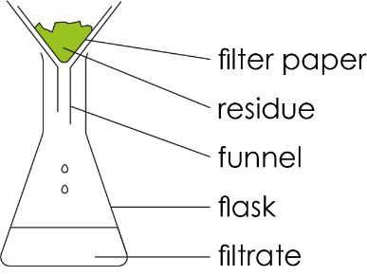
- Name the residue. ________________________________
- Name the filtrate. ________________________________

- Some blue copper sulfate is dissolved in water. The solution is filtered.

- Name the filtrate. _____________________________________________
- Explain why there will be no residue. ________________________________________

__________________________________________________________________________________
- A lot of copper chloride is mixed with water. Not all the copper chloride is able to dissolve. The mixture of copper chloride solution and undissolved copper chloride is filtered.

- Name the residue. _____________________________________________

- Name the filtrate. _____________________________________________
- Some muddy water is collected from a lake. Tiny fragments of mud are mixed with the water making it look cloudy. The water contains natural dissolved minerals. The muddy water is poured through a filter. The mud remains as residue in the filter paper. A chemically pure substance is a single element or compound that is not mixed with any other substance.

Explain why the water that passes through as the filtrate is not chemically pure.

________________________________________________________________________________________________________________________________________________________________________________________________________________________________________________________________________________________________________________________________________

