Atoms and ions

This resource is from the Johnstone’s triangle series, which can be viewed at: rsc.li/3SJLkpr. In this series you will also find our Atoms and ions: Johnstone’s triangle worksheet which introduces the triangle in the context of copper and copper ions, see rsc.li/44ae41B.

Learning objectives
LO | Objective | Where assessed
1 | Complete number line diagrams to show why an atom has no overall charge or an ion has the given charge. | Q1
2 | Distinguish an atom from an ion when given numerical information about the number of protons and electrons. | Q2
3 | Draw electron configuration diagrams for atoms and ions. | Q3
4 | Describe how an atom becomes an ion. | Q3
5 | Identify an atom or ion from the number of protons and electrons. | Q4

How to use the resource

This resource aims to develop learners’ understanding of atoms and ions. The questions encourage learners to compare the numbers of protons and electrons to calculate charge. As a result, learners should develop more secure mental models to support their thinking about this topic.
When to use? |   Introduce |   Develop |   Revise |   Assess
When to use? | Use after initial teaching or discussion of this topic to develop ideas further. You can also use as a revision activity.
Group size? |   Independent |   Small group |   Whole class |   Homework
Group size? | Suitable for independent work either in class or at home. Or use the questions for group or class discussions.
How long? |  |  | 15–30 mins

Johnstone’s triangle

Johnstone’s triangle is a model of the three different conceptual levels in chemistry: macroscopic, sub-microscopic and symbolic. You can use Johnstone’s triangle to build a secure understanding of chemical ideas for your learners.

Find further reading about Johnstone’s triangle and how to use it in your teaching at rsc.li/4mkBWq9

Johnstone’s triangle and this resource

The icons in the margin indicate which level of understanding each question is developing to help prompt learners in their thinking.

 | Macroscopic: what we can see. Think about the properties that we can observe, measure and record.
 | Sub-microscopic: smaller than we can see. Think about the particle or atomic level.
 | Symbolic: representations. Think about how we represent chemical ideas including symbols and diagrams.

The levels are interrelated, for example, learners need visual representation of the sub-microscopic to develop mental models of the particle or atomic level. Our approach has been to apply icons to questions based on what the learners should be thinking about.

Questions may be marked with two or all three icons, indicating that learners will be thinking at more than one level. However, individual parts of the question may require learners to think about only one or two specific levels at a time.

Support

This worksheet is ramped so that the earlier questions are more accessible. The activity becomes more challenging in the later questions. You can give extra explanations for the more challenging questions. If completing as an in-class activity it is best to pause and check understanding at intervals, as often one question builds on the previous one.

It is useful for learners to observe macroscopic properties first-hand. You could circulate examples of substances in the classroom, run a class practical of a chemical reaction or show a teacher demonstration of properties.

Give learners physical models to use, such as a number line and counters.

Additional support may be needed for any learners still lacking in confidence in the required symbolic representation, for example by sharing and explaining a diagram or a simulation that can show movement of the particles.


Answers
- Guidance note: This question supports learners to connect their understanding of positive and negative sub-atomic particles (sub-microscopic understanding) to mathematical understanding of adding positive and negative numbers. The question supports this mathematical understanding with the visual aid of a number line.

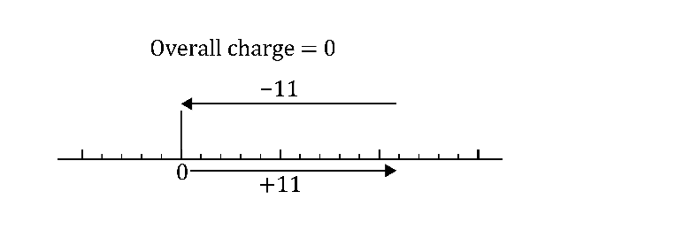
(a)

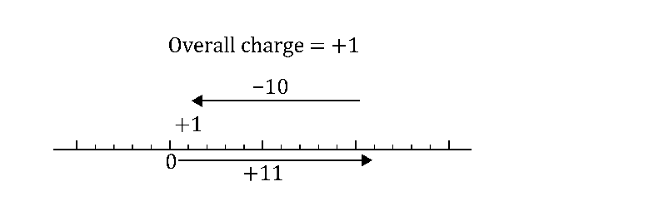

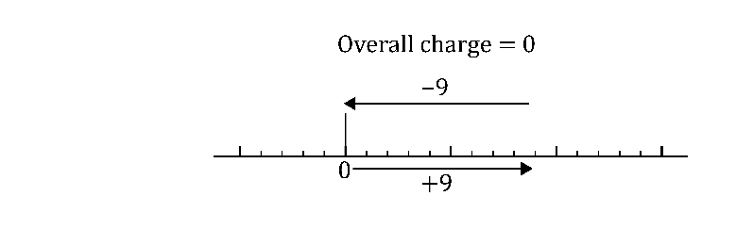

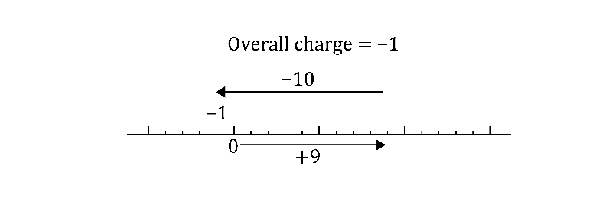

- The number of protons is always the same (and is unique) for any given element. If an ion had a different number of protons to an atom of an element then it would be the ion of a different element.

(The number of protons in atoms of an element can be found in the periodic table and is equal to the atomic number.)

- Guidance note: This question develops learners’ confidence in determining the overall charge of a combination of protons and electrons and hence whether they form an atom or ion (sub-microscopic understanding).
Number of protons | Number of electrons | Total positive charge | Total negative charge | Overall charge | Atom or ion
6 | 6 | +6 | -6 | 0  (+)6 – 6 = 0 | atom
3 | 3 | +3 | -3 | 0 | atom
3 | 2 | +3 | -2 | +1 | ion
9 | 10 | +9 | -10 | -1 | ion
8 | 10 | +8 | -10 | -2 | ion


- Guidance note: This question develops learners’ understanding of how to represent the electronic structure of an atom (symbolic) using the atomic number from the periodic table (sub-microscopic understanding). This question also supports learners to connect the loss of an electron to the +1 charge of the related ion.
- 3
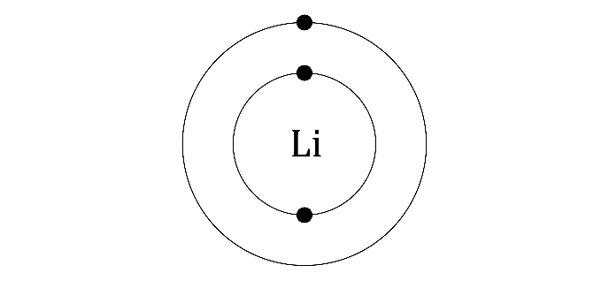

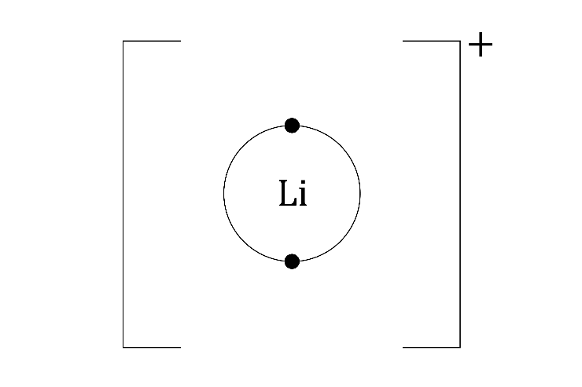
- A lithium atom becomes a positive ion when the atom loses its outer electron.
- Guidance note: This question develops learners’ understanding of how to represent the electronic structure of an atom (symbolic) using the atomic number from the periodic table (sub-microscopic understanding). This question also supports learners to connect the loss of two electrons to the +1 charge of the related ion.
- 12
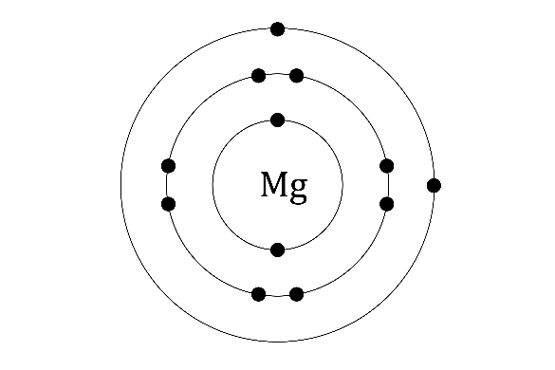
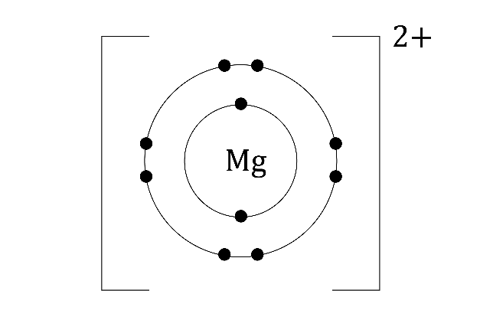
- A magnesium atom loses two (outer) electrons to become a positive ion.
- Guidance note: This question develops learners’ understanding of how to represent the electronic structure of an atom (symbolic) using the atomic number from the periodic table (sub-microscopic understanding). This question also supports learners to connect the gain of an electron to the -1 charge of the related ion.

(a)17
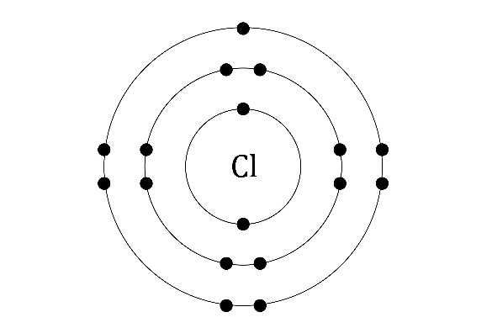

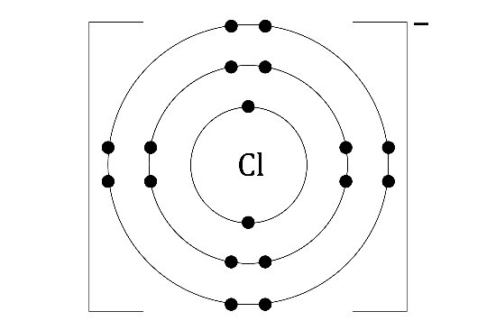

- A chlorine atom gains one (outer) electron to become a chloride ion.
- Guidance note: This question develops learners’ understanding of how to use a combination of information on the number of protons and an electron structure diagram (symbolic understanding) to identify an atom or ion (sub-microscopic understanding). This question demonstrates that an electron structure diagram is not sufficient to identify an atom or ion, without knowing the number of protons.

(a)$Ne$
- ${Na}^{+}$
- ${Mg}^{2+}$
- $F^{-}$
- $O^{2-}$

