Diffusion and chemical reactions

Introduction

These questions are designed to help you to develop your mental models (pictures in your head) of the diffusion of particles. These questions are also designed to help you to connect your understanding of diffusion, solutions and chemical reactions.
 | Macroscopic: what we can see. Think about the properties that we can observe, measure and record.
 | Sub-microscopic: smaller than we can see. Think about the particle or atomic level.
 | Symbolic: representations. Think about how we represent chemical ideas including symbols and diagrams.

Questions

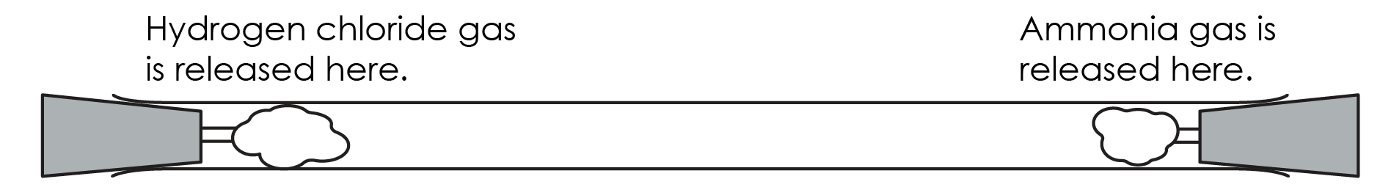
- A teacher sets up a glass tube. They add cotton wool to each end. The cotton wool has been soaked in two different substances.

The diagram below shows the ammonia particles at the very start of the experiment.
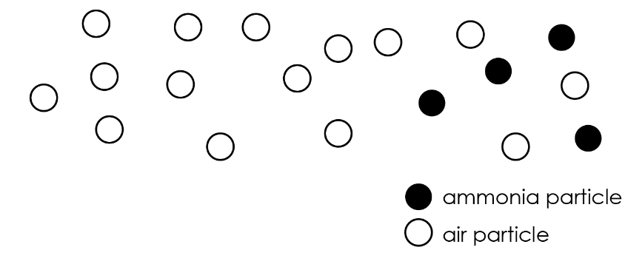
- Colour the diagram below to show what happens to the particles of ammonia and air when the ammonia has diffused further along the tube.
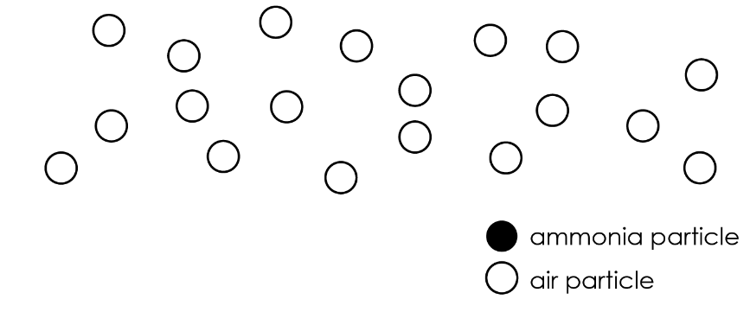

- Ammonia and hydrogen chloride react to form a white solid.

After some time, a white ring of this solid can be observed in the tube.

Complete the paragraph, using the words provided, to explain why the white ring forms.

particles reacted tube solid diffused

The ammonia and hydrogen chloride particles have __________________ and moved away from the ends of the __________________. The white ring has formed because the __________________ have met each other and have __________________ to form the white __________________.

- Particles in the gas state move very fast.

Explain why it takes a long time for the ammonia particles to meet the hydrogen chloride particles.

__________________________________________________________________________________

__________________________________________________________________________________

__________________________________________________________________________________

__________________________________________________________________________________

- Ammonia molecules have a smaller mass than hydrogen chloride molecules.

Why does the white ring form closer to the left of the tube? Explain your answer.

__________________________________________________________________________________

__________________________________________________________________________________

__________________________________________________________________________________

__________________________________________________________________________________

- Potassium iodide and lead nitrate are made of white crystals which can dissolve.

Potassium iodide and lead nitrate react to create a new substance called lead iodide. Lead iodide is yellow. Lead iodide does not dissolve in water.
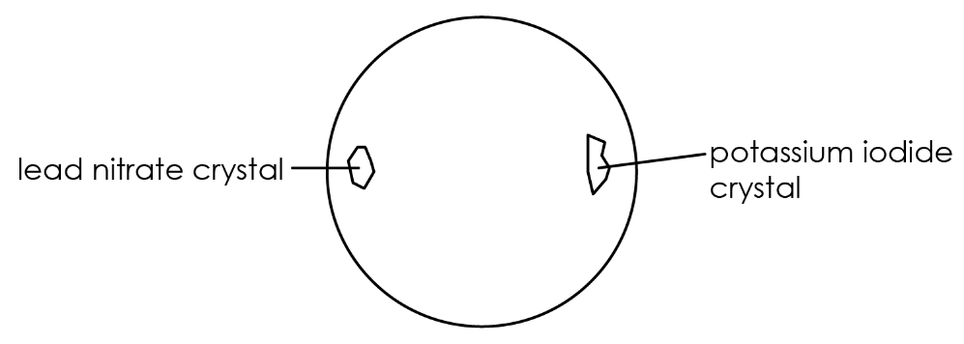
- A student places a crystal of potassium iodide and a crystal of lead nitrate at the edge of a drop of water. The student then waits for 10 minutes.

Complete the paragraph, using the words provided, to describe what happens next.

solution dissolves diffuse

The potassium iodide gradually __________________ in the water. This forms potassium iodide __________________ near the crystal. Lead nitrate __________________ forms near the lead nitrate crystal. Gradually potassium iodide __________________ from the right of the droplet. Lead nitrate __________________ from the left of the droplet.

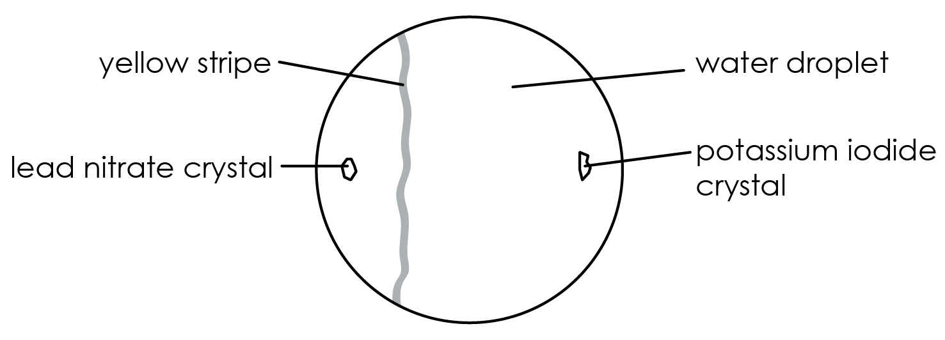
After leaving the experiment longer a yellow stripe appears.

(b) Name the substance that is forming the yellow stripe.

__________________________________________________________________________________

(c) Suggest why the stripe is nearer the left of the droplet.

__________________________________________________________________________________

__________________________________________________________________________________

