States of matter

Matter is anything that has mass and takes up space. Everything around us is made of matter and there are three states of matter – solid, liquid and gas. Particle diagrams explain the properties of solids, liquids and gases and they show how the particles are arranged.

Diagrams, definitions and properties
 | Solid | Liquid | Gas
Diagram | 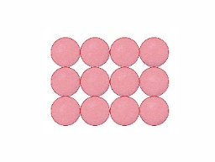 | 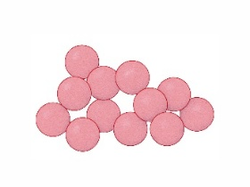 | 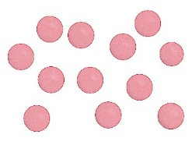
Definition | a state of matter with a defined shape and volume and where the particles are touching and vibrating | a state of matter with a defined volume but not a defined shape and where the particles are touching and moving randomly | a state of matter with no defined shape or volume and where the particles move randomly and have a large distance between them
Shape | fixed | takes shape of the bottom of the container | takes shape of container
Volume | fixed (cannot be compressed) | fixed (cannot be compressed) | can be compressed
Particle movement | can vibrate in place but cannot move out of position | constantly moving and can slide over each other | constantly moving
Kinetic energy | low | medium | high
Fluidity | cannot flow | can flow | can flow
Real-world example: making coffee | ground-up coffee beans | water in the coffee machine | when the water is heated in the coffee machine, some of the water becomes a gas as steam

Changes of state

During changes of state, the arrangement and energy of the particles must change.

When a solid reaches its melting point, it gains energy and turns into a liquid. The forces between particles are overcome and the particles can slide past each other.

When the temperature of a liquid increases, particles at the surface gain energy and overcome the forces of attraction. The particles turn into a gas (evaporate) and move randomly and freely. This can happen below the boiling point.

When the temperature of a gas decreases quickly, the particles lose energy and stop moving about. It turns into a solid, without first becoming a liquid.

Did you know … ?

Water is an example of a compound which is found naturally in all three states of matter – ice as a solid, water as a liquid and water vapour as a gas.

