Reactant and product substances

Introduction

These questions are designed to help you to develop your mental models (pictures in your head) of reactants and products. Use the icon in the margin to find out which level of understanding the question is developing.
 | Macroscopic: what we can see. Think about the properties that we can observe, measure and record.
 | Sub-microscopic: smaller than we can see. Think about the particle or atomic level.
 | Symbolic: representations. Think about how we represent chemical ideas including symbols and diagrams.

Questions
- At room temperature the chemical substance water is in the liquid state.
- If liquid water is placed in a freezer it will change into ice.

Name the chemical substance that ice is made from.

__________________________________________________________________________________
- If water is heated in a kettle, it will boil and change into water vapour.

Name the chemical substance that water vapour is made from.

__________________________________________________________________________________
- During a chemical change, a new substance or substances are formed.

Explain why freezing and boiling are not chemical changes.

__________________________________________________________________________________
- Name the type of change that freezing and boiling are examples of.

__________________________________________________________________________________


- Different elements and compounds have different properties. They have different melting and boiling points and so at room temperature they may be in the solid, liquid or gas state. They can also have different colours.
- Match the elements and compounds to the descriptions.

copper oxide |  | colourless gas
copper |  | colourless gas
oxygen |  | shiny orange solid
carbon |  | green solid
carbon dioxide |  | black solid
copper carbonate |  | black solid

- Name the element or compound represented by each symbol of chemical formula. The elements and compounds are listed in part (a).

- $C$ __________________________
- $O_{2}$ __________________________
- ${CO}_{2}$ __________________________
- $Cu$ __________________________
- $CuO$ __________________________
- ${CuCO}_{3}$ __________________________

- Explain why copper carbonate has different properties to copper, carbon and oxygen.

__________________________________________________________________________________

- A reactant is a substance that is present before a chemical reaction. A product is a substance that is formed during the chemical reaction.

Some copper is heated in the air. At the start the copper is shiny and orange in colour. At the end a black solid is observed.

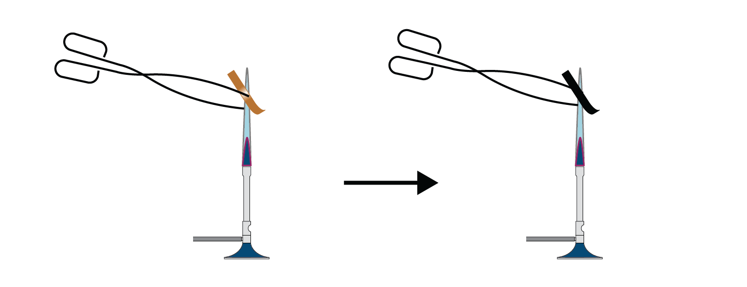
- Name the shiny orange reactant.

__________________________________________________________________________________

- Name the other reactant (that cannot be seen).

__________________________________________________________________________________

- State where the other reactant comes from.

__________________________________________________________________________________

- Explain why the following statement cannot be true.

“The copper has changed colour from orange to black.”

__________________________________________________________________________________

__________________________________________________________________________________

- Name the black substance that is formed as the product.

__________________________________________________________________________________


- Reactants and products can be different colours.
- Look at the table below.

Reactant 1 | Reactant 2 | Product
orange shiny solid | colourless gas | black solid
silver grey solid | yellow-green gas | white solid
silver grey solid | yellow solid | black solid

Is it possible to predict the colour of the product from the colour of the

reactants?

__________________________________________________________________________________
- Select the answer that best describes the colour of an iron atom.

grey black no colour silver
- The picture below shows a particle diagram for iron.

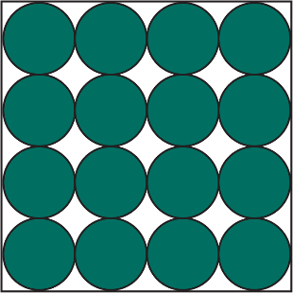

Suggest why it may cause misunderstandings to show iron atoms as grey or sulfur

atoms as yellow.

__________________________________________________________________________________

__________________________________________________________________________________

- Explain why the colour of iron sulfide cannot be a mixture of the colours of the atoms of iron and sulfur.

__________________________________________________________________________________

__________________________________________________________________________________

