How atoms are made up
Criteria sheet

- Atoms have a nucleus that contains protons and neutrons.
The nucleus is surrounded by electrons in different shells.

I think that I know this
I have shown that I know this

- The relative masses of a proton, neutron and an electron.

I think that I know this
I have shown that I know this

- The relative charges on a proton, neutron and an electron.

I think that I know this
I have shown that I know this

- All atoms in one element have the same number of protons in the nucleus.
Atoms of different elements have different numbers of protons in
the nucleus.

I think that I know this
I have shown that I know this

- The number of protons in the nucleus, the proton number, is also called the atomic number.

I think that I know this
I have shown that I know this

- The number of protons and neutrons in the nucleus is called the mass number.

I think that I know this
I have shown that I know this

- Showing the symbol of an element, its atomic number and its mass number in shorthand form, like this:

${}_{6}^{12}{}C$

I think I can do this
I have shown that I can do this

- Filling in the gaps in a table like this:

Element | Symbol | Number of protons | Number of neutrons | Number of electrons | Atomic number | Mass number
 | C | 6 |  |  |  | 12
Lithium |  |  | 4 | 3

I think I can do this
I have shown that I can do this

- How the atoms of isotopes of elements are different from one another.

I think I can explain this
I have shown that I can explain this

10. The correct arrangements of electrons in shells, for elements of
atomic number 1 to 20, in diagrams like this:

Sodium 2.8.1
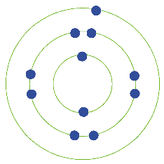

I think I can draw them
I have shown that I can draw them

