The composition and formula of water

Learning objectives
- Describe how water is formed during the redox reaction of copper oxide with hydrogen.
- Accurately record experimental observations and data.
- Determine the formula of water from the experimental data.

Introduction

Your teacher will demonstrate the reaction between copper oxide and hydrogen gas, in which water is a product. During the demonstration you will record your observations and use then use the experimental data to determine the formula of water.

Questions
- Write the word equation for the reaction.

__________________________________________________________________________________

- Describe what happens during a redox reaction. Include what is oxidised and what is reduced in this experiment.

__________________________________________________________________________________

__________________________________________________________________________________

__________________________________________________________________________________

- Label the diagram
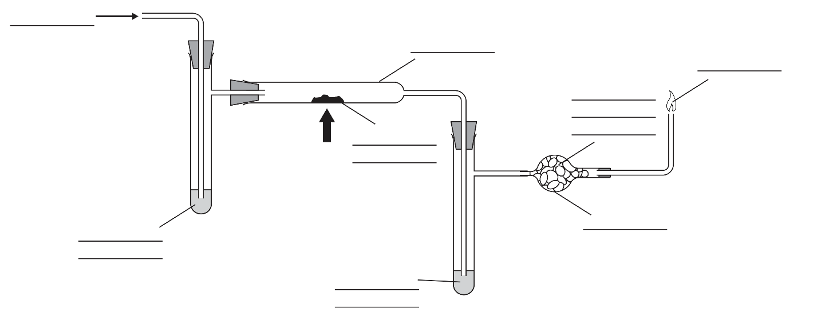
- State why concentrated sulfuric acid was added to the side arms.

______________________________________________________________________________

______________________________________________________________________________

- List two safety precautions taken during the reaction
- _________________________________________________________
- _________________________________________________________

- Record the masses in the table

 | Mass before heating / g | Mass after heating / g

Mass of combustion tube and contents

Mass of combustion tube, side arm and contents

- Note your observations in the table.

Use the final column to explain your observation.
 | Observation | Explanation

Before heating

During heating

After heating

- Use the data recorded in your table to calculate:

(a) The mass of oxygen lost from the copper oxide _________ g

(b) The mass of water formed during the reaction ___________ g

(c) The mass of hydrogen in the water formed _____________ g

- The relative atomic mass of oxygen is 16 and the relative atomic mass (A_{r}) of hydrogen is 1.

Calculate:
- The number of moles of oxygen in the water = __________ mol
- The number of moles of hydrogen in the water = _________ mol
- The mole ratio of H:O in the water = ________________

- Write the formula of water and describe its composition.

______________________________________________________________________________

______________________________________________________________________________

- Write the balanced symbol equation for the reaction.

_____________________________________________________________________________

