What sank the Kursk nuclear submarine?
Did you know?
About seismology
When an earthquake, quarry blast, nuclear weapons test or other event happens underground, the earth shakes. The shakes are called seismic waves. These can be detected using a seismometer, which changes the ground movement into a pen movement. The line produced by the pen is called a seismogram. The seismogram shows the size, or amplitude, of the ground movement as time goes on. The size may be reported as a Richter scale value, which is familiar from earthquakes.
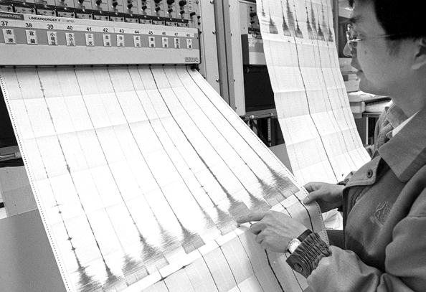
Seismogram of the Taiwan earthquake of 2nd November 1999
Reproduced with permission from Stephen Atkinson, PA Photos.
Seismometers are set up at various places around the world. A set of seismograms allows siesmic sources to be located in space and time.
Any source causing a ground disturbance produces its own wave pattern and shape, like a fingerprint. For example, artificial seismic sources are used to search for oil and gas in the earth. The shape and pattern of the waves change if oil or gas are present. Also, different sorts of explosions will produce specific wave shapes. This means that seismology has helped to keep international peace, because underground nuclear weapons tests can be detected.
The unique wave pattern makes nuclear tests and any other types of explosion difficult to hide.



